sudo apt-get update

If you are using Python2 then type
sudo apt-get install python-pip
sudo pip install virtualenv
If you are using Python3 then type
sudo apt-get install python3-pip
sudo pip3 install virtualenv

whenever you start a new project, you can create a virtual environment for it. Start by creating and moving into a new project directory:
mkdir projectname
cd projectname

Create virtual Environment in that directory;
virtualenv typeyourenvironmentname

Activating your virtual environment
source yourenvironmentname/bin/activate
Installing django in that environment for both python2 and python3 users:
pip install django

For checing django version type:
django-admin --version

Advantages of Django
Here are few advantages of using Django which can be listed out here −
- Object-Relational Mapping (ORM) Support − Django provides a bridge between the data model and the database engine, and supports a large set of database systems including MySQL, Oracle, Postgres, etc. Django also supports NoSQL database through Django-nonrel fork. For now, the only NoSQL databases supported are MongoDB and google app engine.
- Multilingual Support − Django supports multilingual websites through its built-in internationalization system. So you can develop your website, which would support multiple languages.
- Framework Support − Django has built-in support for Ajax, RSS, Caching and various other frameworks.
- Administration GUI − Django provides a nice ready-to-use user interface for administrative activities.
- Development Environment − Django comes with a lightweight web server to facilitate end-to-end application development and testing

Windows users open windows powershell and move in the folder where you want to setup the django files i will advice from the powershell starting move to desktop and then the following command this will create the folder of this on your desktop only
Now for Both windows and linux users:

Type the below line in order to create you first django project named mysite:
django-admin startproject mysite
This will create a folder mysite with different files in it.
Now this will create a folder named mysite now move inside that folder from your terminal
type:
python manage.py migrate
followed by
python manage.py runserver

and now visit the url in order to check all the set up is working fine now i will explain what we have done
the url would be like 127.0.0.1:8000
now you can see the the webserver is running and is in the debug mode

as you can see the folder of you will be something looking like this
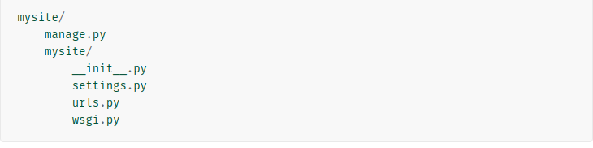
So Now what these files are:
1) The outer mysite/ root directory is just a container for your project. Its name doesn’t matter to Django; you can rename it to anything you like.
2.)manage.py: A command-line utility that lets you interact with this Django project in various ways.We can say it is the local admin of the project and we have to execute every command using it likewise we have used the runserver and migrate things.
3.)The inner mysite/ directory is the actual Python package for your project. Its name is the Python package name you’ll need to use to import anything inside it (e.g. mysite.urls).
- mysite/__init__.py: An empty file that tells Python that this directory should be considered a Python package.
- mysite/settings.py: Settings/configuration for this Django project.
- mysite/urls.py: The URL declarations for this Django project; a “table of contents” of your Django-powered site. We use this to match up the urls which should be typed and what page should be displayed according to it.
- mysite/wsgi.py: An entry-point for WSGI-compatible web servers to serve your project.

Also if you can see there is a file of db.sqllite3 which your database file for django which we will be using you can use different databases also like mysql , postgresql_psycopg2,oracle etc
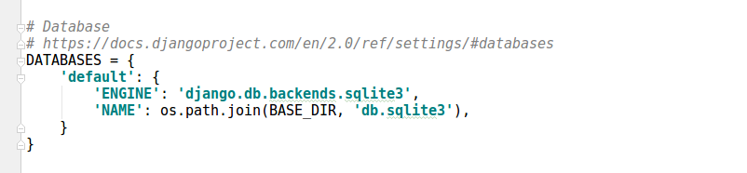
Bydefault your database is sqllite3 you can change the database by going in the setting file of your mysite folder you will file something like this

when you want to change the database change sqllite3 with your database name in ENGINE and change the name of the file also
But for today we will work only with sqlite3

As per now we have not disscussed about anything why django is MVC kind of pattern

So let go further in developing an app in django in your project and learn about MVC pattern through it

So what is an app in django?
An application tries to provide a single, relatively self-contained set of related functions. An application is allowed to define a set of models (though it doesn’t have to) and to define and register custom template tags and filters

So we will be not be doing much work in our main site we will be dividing the work in different apps so as to make the work understandable and simpler

so type the following in order to create app

python manage.py startapp myapp

What this will do is that it will create and app in your project named myapp
You can see the structure of your project you will find a new folder formed in it.
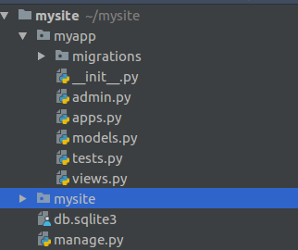

This is the structure of your folder now
Here you can see is different files which django had already created for you

- __init__.py − Just to make sure python handles this folder as a package.
- admin.py − This file helps you make the app modifiable in the admin interface.
- models.py − This is where all the application models are stored.
- tests.py − This is where your unit tests are.
- views.py − This is where your application views are.
- apps.py – This is where we write app configuration like name etc.

So now you have created your app so now how the django will now you have created the app?
So in order to make it know thats where the settings the come in roll
see the settings files of your mysite
you will find something written like this :
# Application definition
INSTALLED_APPS = [
'django.contrib.admin',
'django.contrib.auth',
'django.contrib.contenttypes',
'django.contrib.sessions',
'django.contrib.messages',
'django.contrib.staticfiles',
]
in this include your app name like this ,
# Application definition
INSTALLED_APPS = [
'django.contrib.admin',
'django.contrib.auth',
'django.contrib.contenttypes',
'django.contrib.sessions',
'django.contrib.messages',
'django.contrib.staticfiles',
'myapp',
]
all the apps that you can see are auto-generated by django and are used in developing the website the more you will work on django you will come to know about each and every app

So now we are done with creating our app so now again you will be thinking this is completely different where is MVC and why MVC in django?

See as you created your app you have seen a folder of models in your app.

So what u understood by models as mishal had already explained so someone from you ?

The model(M) is a model or representation of your data. It’s not the actual data, but an interface to the data. The model allows you to pull data from your database without knowing the intricacies of the underlying database.

Now there is another folder called views in your app,
So the views in django is
“View,” the business logic layer. This layer contains the logic that accesses the model and defers to the appropriate template(s). You can think of it as the bridge between models and templates.
Instead of controllers there is one other thing in django which is templates
“Template,” the presentation layer. This layer contains presentation-related decisions: how something should be displayed on a Web page or other type of documen

So we can say django is more of MTV pattern then MVC pattern the templates are similarly to views in MVC and we can say views in django are similar to that of controllers in MVC

So now as we say different person can work on different components simultaneuously thats what MVC or MTV is all about the front end developer can work on the layout of by working on the templates and views
and the backend server side people can work on the models thing and integrate them so the work will now stop thats the advantage of MTV or MVC pattern

Let us consider and example:
So now create one view for your page;

Create a views file in your mysite where setting.py and other files are present and in it write the following we will be creating a very basic view

from django.http import HttpResponse

def home(request):
html="<h1> this is the homepage<h1>"
return HttpResponse(html)

and in the views fine of your myapp directory write the following:
from django.http import HttpResponse
def home(request):
html="<h1> this is the homepage of your myapp<h1>"
return HttpResponse(html)
and in the urls file of mysite project should look like this :

from django.conf.urls import url
from django.contrib import admin
from django.urls import path
from myapp import views as myappview
from mysite import views
urlpatterns = [
path('admin/', admin.site.urls),
url(r'^$',views.home),
url(r'^myapp/$',myappview.home),
]

now run your localhost you will see the change

see what wew have done is created a normal view for displaying the text “This is the homepage”
and return it

As it is serverside thing(client-server ) most the thing will work are request and response the client will do a request according to this request we will be responding

The url pattern will match the url of the website and return according view.
We have written url(r’^$’,views.home)

here r stands for regular expressions and the ^ marks the starting and the $ marks the ending so what doe it means is there is nothing in starting and ending means this is the homepage of your website it will open whenever you just write the site name

So first of all url will be matched and according to match it will call the view means request the view which we have passed as the second parameter

So the the view which we have created will be called and it will submit a httpresponse as the html variable which we have created.

Similarly url(r’^myapp/$’,myappview.home) this will go to the views of your app and then call home view from there

The url which this is matching is http://127.0.0.1:8000/myapp/
When only you go to this url that view will be called.

See this is the very basic example not the proper one you can make it more attractive using the templates and the static html pages all the other front end thing which you have learnt
in the starting of the mentorship

in the models file of your app write the following we will be creating our first model:

from django.db import models

class book(models.Model):
book_name=models.CharField(max_length=50)
book_author=models.CharField(max_length=50)

def __str__(self):
return self.book_name

so what this is doing is that we creating a model or say a table in database which will have book_name and book_author columns in the database and i will explain the use of the predefined function later

What you have done just now is that you have provided the definition of the models means you have provided what should be structure but you have make changes in the database of your project also so in order to do this you have to do the following

now run the following commands:

python manage.py makemigrations myapp

This will create the migrations from you myapp to the mysite module.
As you will be thinking how databases in django understand what we are writing in python;
the thing is that django is so smart it converts the python written code into sql and then execute it.

You can see this how django had interpreted of our migration:

write the following line :

python manage.py sqlmigrate myapp 0001

This will show us the sql statement
now execute the final statement to make migrations to the database

python manage.py migrate

Now we have created the model and migrated it so its time to create some records inside it

now write in the terminal or the powershell(if windows)
op into the interactive Python shell and play around with the free API Django gives you. To invoke the Python shell, use this command:

python manage.py shell

this will open the python shell offered by Django

So now we will add some of the objects to our sqllite database writet hte following things:

from myapp.models import book

Now create an object of your class

book1=book()
book1.book_name="Introduction to Django"
book1.book_author="No idea who had written"
book1.save()

Or

book2=book(book_name="Hello world", book_author="new organisation")
book2.save()

Here what we have done is we have created two records in our database you can view the views created as

book.objects.all()

you wil see the records i had told you i will explain you the funtion def __str__(self) later:

now exit from the shell using

exit()

and remove that lines and again write
from myapp.models import book
book.objects.all()
Now you yourself see the difference got the difference ?

Now we will create a very basic interaction of model with the views and we will use the templates also :

first of all create a templates folder inside your myapp folder

be carefull the name of the folder should be “templates” only not anything else

in that folder create an html file named bookdetails.html write the following code in it

<!DOCTYPE html>
<html lang="en">
<head>
<meta charset="UTF-8">
<title>Book list</title>
</head>
<body>
<h2><center>List of Books</center></h2>
{% for bookobj in book %}
<ol><h4> {{bookobj.book_name}}</h4></ol>
{% endfor %}
</body>
</html>
and in the views file of the myapp edit the following things:

from django.http import HttpResponse
from django.shortcuts import render
from .models import book
def home(request):
html="<h1> this is the homepage of your myapp<h1>"
return HttpResponse(html)
def booklist(request):
return render(request,'bookdetails.html',{'book':book.objects.all()})

and in the url.py file of the mysite edit the following

from django.conf.urls import url
from django.contrib import admin
from django.urls import path
from myapp import views as myappview
from mysite import views
urlpatterns = [
path('admin/', admin.site.urls),
url(r'^$',views.home),
url(r'^myapp/$',myappview.home),
url(r'^booklist/$',myappview.booklist),
]

now run your localhost and visit the url:
http://127.0.0.1:8000/booklist/
you can see the name of the books which we had saved in the database
The above is the most simple demonstration of django you can do big things using it

So we get to the last topic of todays session which is django administration:

in shell

write the following to create the admin user :

python manage.py createsuperuser

Now in the admin file of myapp folder write the following line

admin.site.register(book)

now run your localhost
and visit

http://127.0.0.1:8000/admin/

You will see the admin interface this is the inbuild interface provided by the django and this is the speciality of django it gives you the admin access log in into it and you will find the different things

you will see the users , groups ,other details book model can also be seen i.e you can access the database records edit , delete , insert etc
and you can make other as user also
This work all can be managed by django administration easily

So thats all for the session

